**Diwali sales analysis report**

**Objective**

This is the data of sales made by a company during Diwali through this they want us to analyse it and find out which is Goof has made the most sales and which gender has made the most purchased which reason has seen the hajj sale to this they can make his strategy in future and improve their sales and orders and through knowing the customer’s experience.

So that the company can know where they have made mistake and which field they have to improve how to attract the customer for this they will also make new offer.

**Research questions**

* Which age group has seen the highest sale
* Find out according to gender with a male or female has the highest sale.
* By analysing the given data find out in which age group the cells have been highest and in which have been less and also find out the difference between them.
* Analysing the given data to find out which state have the highest sale and which state have the least sale
* Analysing the given data find out whether the sales have happened more among married people or among Unmarried people and what is the percentage
* Find out the sales according to the occupation of pupil which occupation have more sales and which occupation have less sales
* Find out the sale by product category.
* Find out the ratio between which zone have seen the maximum sale by the company and what has been the percentage

**Exploratory data analysis**

**By Gender**

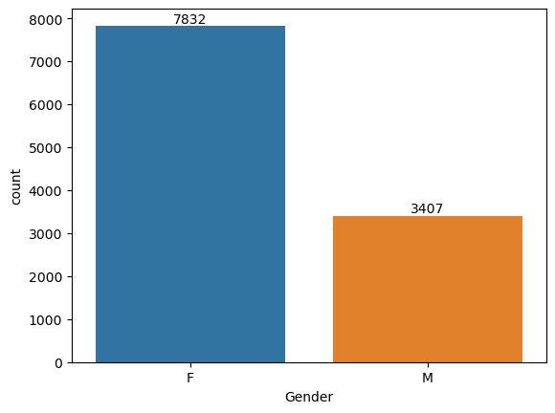

About the Bar chart we can see that company has made sales among the female category. Where is sales among men have been seen to be very low.

**Sales By Age**

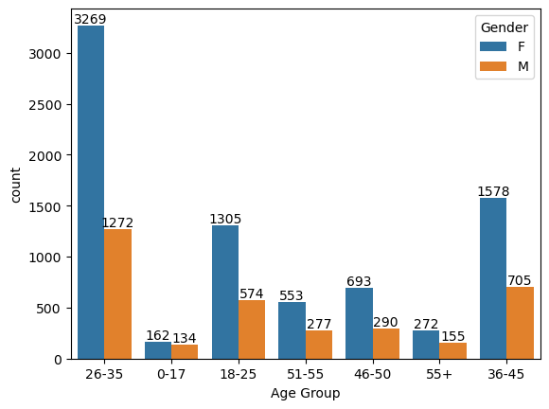

According to the graph made above it is known that the sales have been highest among the People of 26 to 35 year where is the sales have been very less among the Peoples of zero to 17 years of age.

**Sales by states**

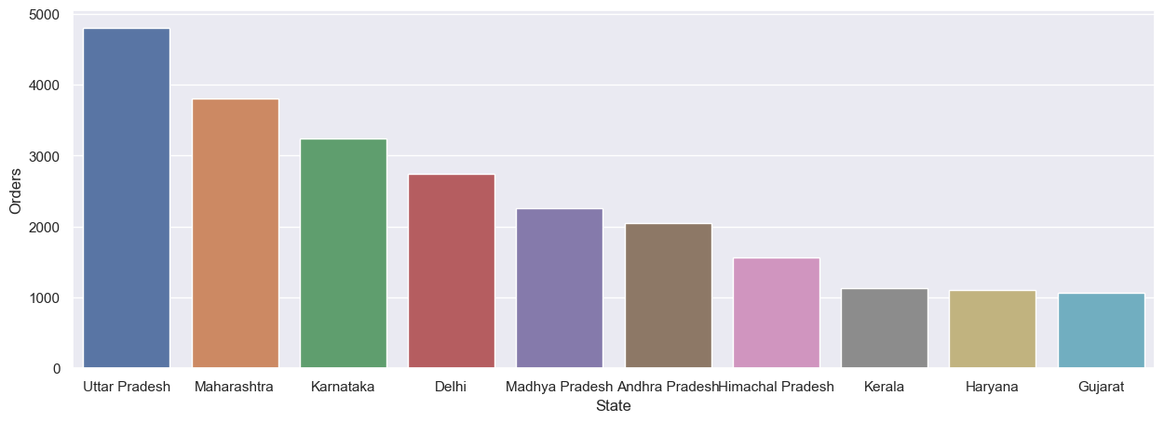

The chart prepaid by analysing the giving data so that Uttar Pradesh Maharashtra ,Karnataka is the state via the sales are the high and where is Haryana and Gujarat are the state where the order and sales of the product are very less

**Sales by marital status**

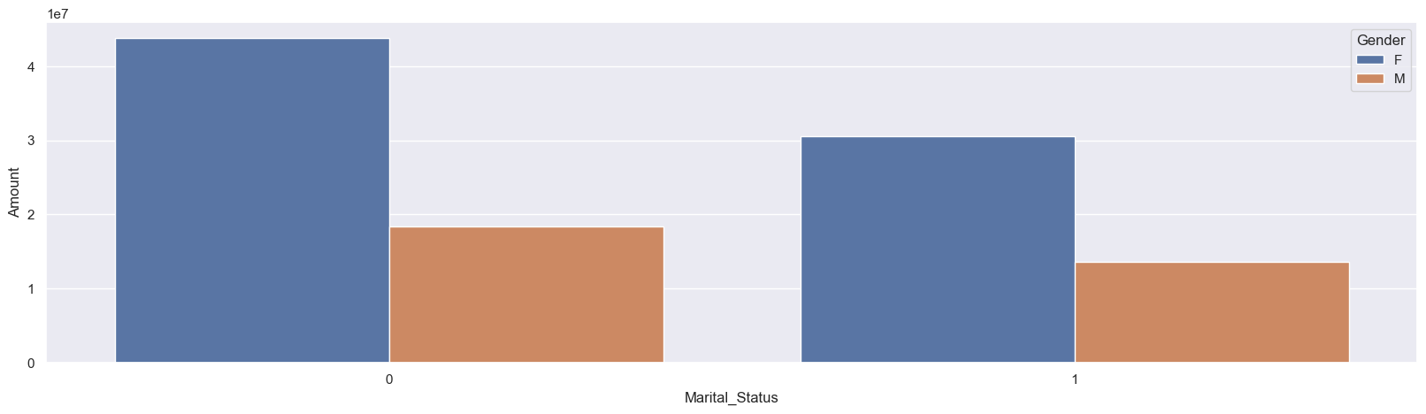

According to the graph given a we can see that the company has made more sales among the married people where is the sale have decreased among the unmarried people and among the married people also the sales have been more by women

**Sales by occupation**

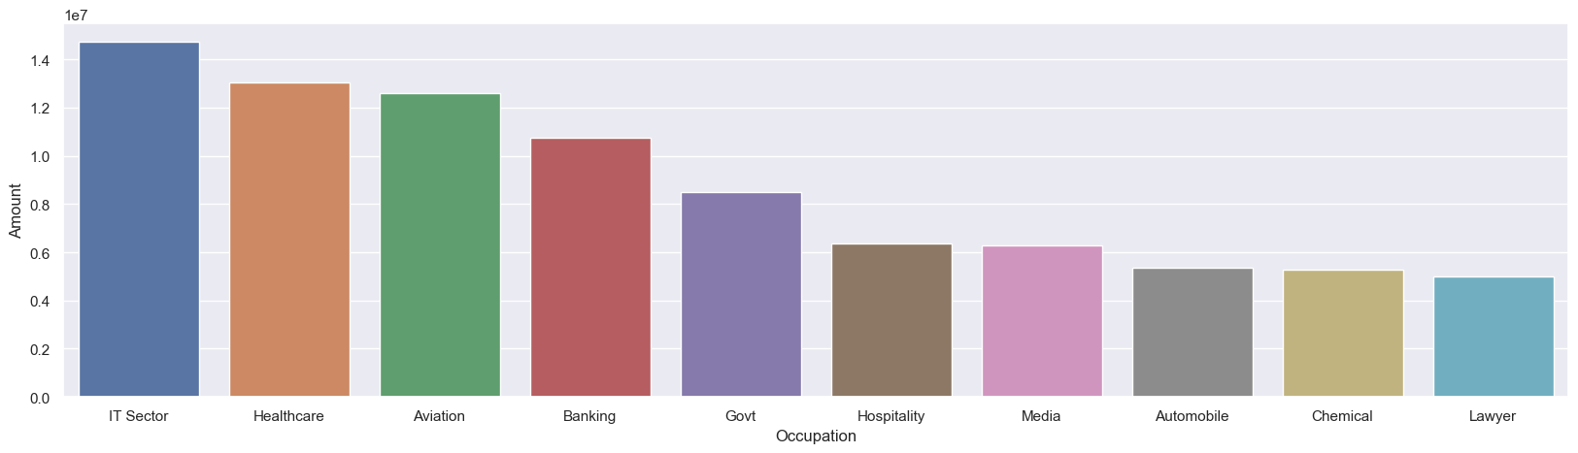

According to the chart we can see that more buying has been done by people from it sector and more buying has also been done in healthcare whereas there has been less buying done by Peoples From lawyer and automobile occupation.

**Sales by product category**

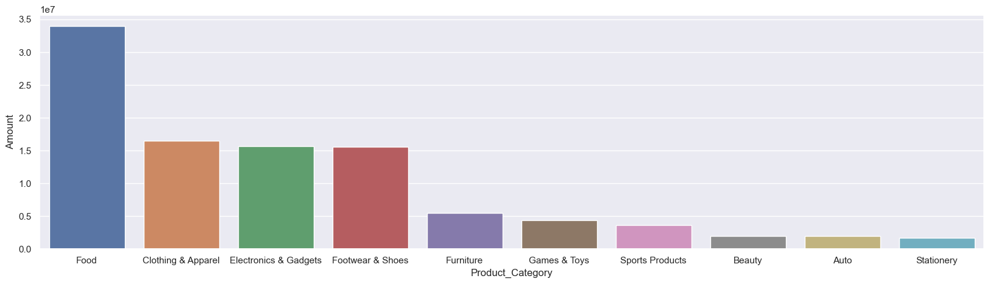

See the graph made by analysing the data we can see that the maximum sales by company have been done in food And clothing and electronic gadgets. Where air sales has done by company leased in category of beauty and stationery.

**Sales by Zone**

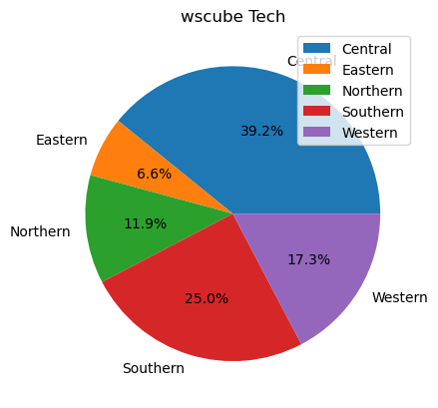

Through the pie chart we can say that maximum sale have been made by the company in the central zone where as less sales have been done by the company in the eastern zone.

**Insights/suggestion**

* Develop and promote products that specifically appeal to men, considering their preferences.
* Create marketing campaigns targeting the age group of 0-17 to increase awareness and interest among younger customers.
* Implement targeted marketing campaigns in Haryana and Gujarat to boost sales.
* Consider regional preferences and cultural factors to tailor products and promotions.
* Introduce promotions or products designed to cater to unmarried individuals.
* Understand the specific needs and preferences of unmarried consumers to tailor marketing strategies accordingly
* Explore partnerships or collaborations with professionals in the legal and automobile sectors to create specialized promotions.
* Conduct market research to understand the specific needs of individuals in these occupations and adjust product offerings accordingly.
* Develop targeted marketing campaigns for beauty and stationery products to increase sales in these categories.
* Consider bundling or discount strategies.

**Summary**

In order to enhance sales, the company should focus on developing and promoting products tailored to men's preferences, aiming to create targeted marketing campaigns for the age group of 0-17 to capture the interest of younger customers. Additionally, the implementation of specialized marketing strategies in Haryana and Gujarat, accounting for regional preferences and cultural factors, could boost sales in those areas. Introducing promotions and products designed for unmarried individuals requires a thorough understanding of their specific needs, while exploring collaborations with legal and automobile professionals necessitates market research to tailor offerings accordingly. Furthermore, the company should develop targeted marketing campaigns for beauty and stationery products, considering bundling or discount strategies to increase sales in these categories. By addressing these insights, the company can create a more personalized and effective approach to drive overall sales growth.